**Selenium**

1. Introduction to Selenium

* Selenium is an Open – source Test Automation tool.
* Key concepts of selenium are –
* Selenium WebDriver
* Selenium IDE
* Selenium GRID
* Used for testing web applications on multiple browsers like Firefox, Chrome, IE, Edge, Safari, Opera.
* Selenium supports multiple operating systems like Windows, MacOS, Linux.
* Selenium supports multiple programming languages such as Java, Python, C#, Java Script, and Ruby.

Go through with the selenium website for more details [www.selenium.dev](http://www.selenium.dev).

1. Selenium WebDriver Architecture

1. How to Install Java on Windows OS

Step – 1: Open <https://www.oracle.com/in/java/technologies/downloads/>

Step – 2: Select JDK version and OS version and download .exe file.

Step – 3: Once downloaded, open and click on install.

Step – 4: Add java to the environment variables.

1. How to Install Eclipse on Windows OS

Step – 1: Open <https://www.eclipse.org/downloads/>

Step – 2: Select the latest version and click on download.

Step – 3: Once downloaded, Open the application, and click on install.

1. How to setup Selenium WebDriver in Eclipse IDE

We can setup selenium WebDriver in Eclipse IDE in two ways.

* Using jar file

By creating a java project, we can add the latest version of selenium jar file.

* Using pom.xml file

By creating a maven project, we can add the dependencies of selenium from maven repository <https://mvnrepository.com/>.

1. How to run tests on different browsers

To run a test case, we need browser types.

* Chrome Browser:

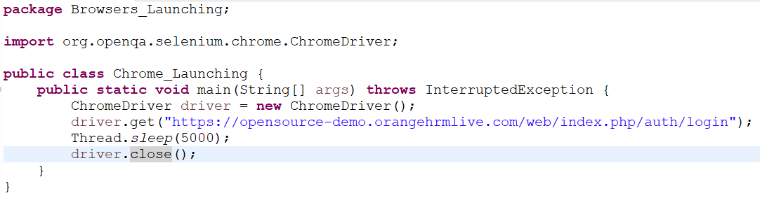

* Microsoft Edge Browser:

1. Maven Introduction and Installation

* Maven: Maven is a build management tool which is provided by Apache Software foundation, and it is a completely open-source tool.
* Advantages:
* It gives project structure.
* It has POM (Project Object Model).XML.
* It generates reports.
* It generates documentation.
* Pom.xml has two entries – dependencies and plugins.
* Dependencies: Responsible for downloading third party libraries or jars like drivers into your project.
* Plugins:
* Controls the entire project.
* Contains different types of configurations on which our project will run.
* After adding dependencies, pom.xml will be –

1. How to manage dependencies with Maven

Add the dependency tag in pom.xml and explain the use of tools that we add.

1. How to use WebDriver Manager

In older versions of selenium, we use the system properties and add the browser name and path of that browser.

If browser updates, then we also need to update the browser and add the updated browser driver.

To solve this problem, we can use WebDriver Manager.

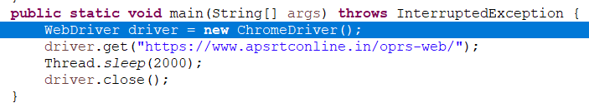

1. How to write first testcase in selenium

Requirements -

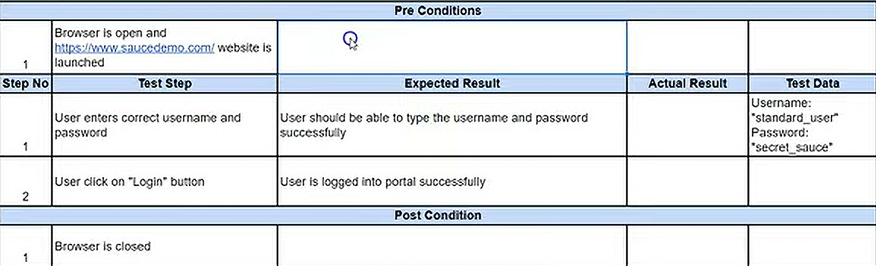

Test Case -

